**Nama : Evi Susilowati**

**NIM : 18090022**

**Kelas : 5C**

**PRAKTIKUM 2**

* **Source Code**
* latihan1.php 🡪 application/controllers
* latihan2.php 🡪 application/controllers
* Model1.php 🡪 application/models
* view-latihan2.php 🡪 application/views
* **URL**
* <http://localhost/pustaka_booking/index.php/latihan1>
* <http://localhost/pustaka_booking/index.php/latihan1/penjumlahan/5/5>
* <http://localhost/pustaka_booking/index.php/latihan2/penjumlahan/5/5>
* **Capture Hasil**
* latihan1

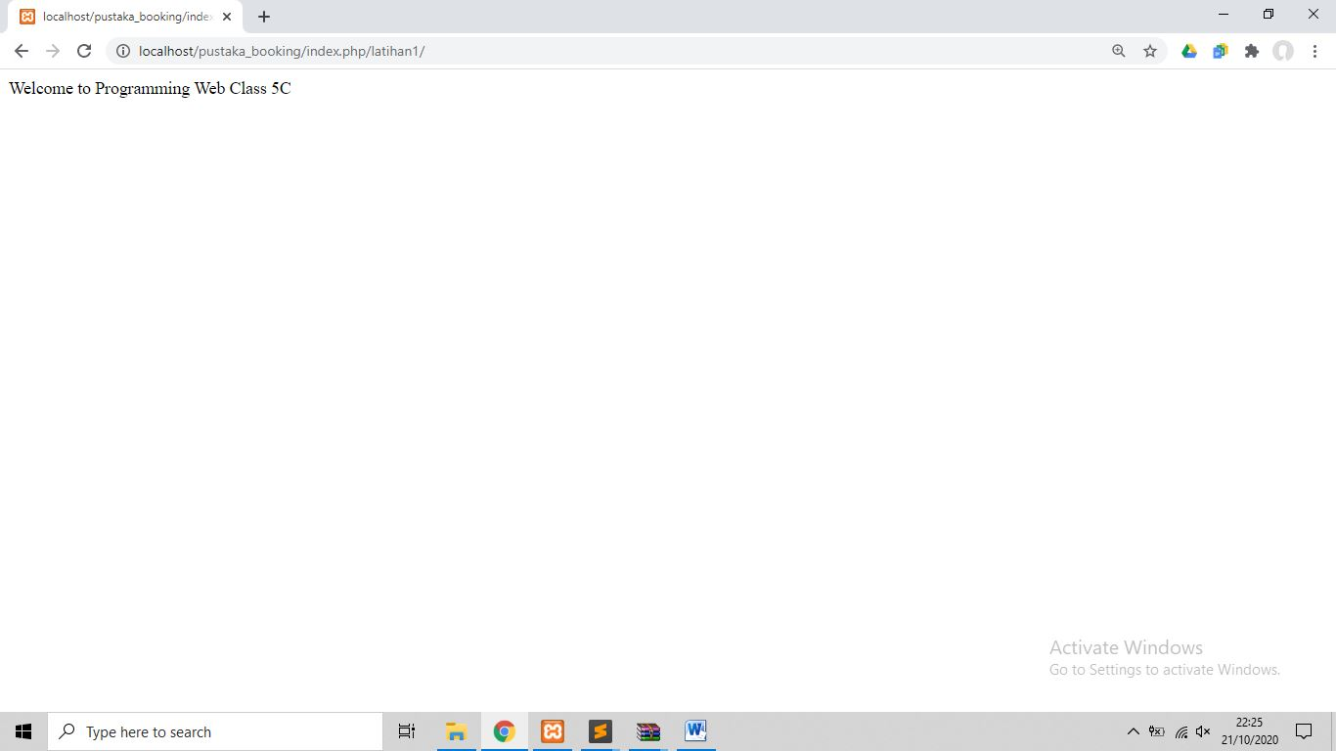

* latihan1 penjumlahan

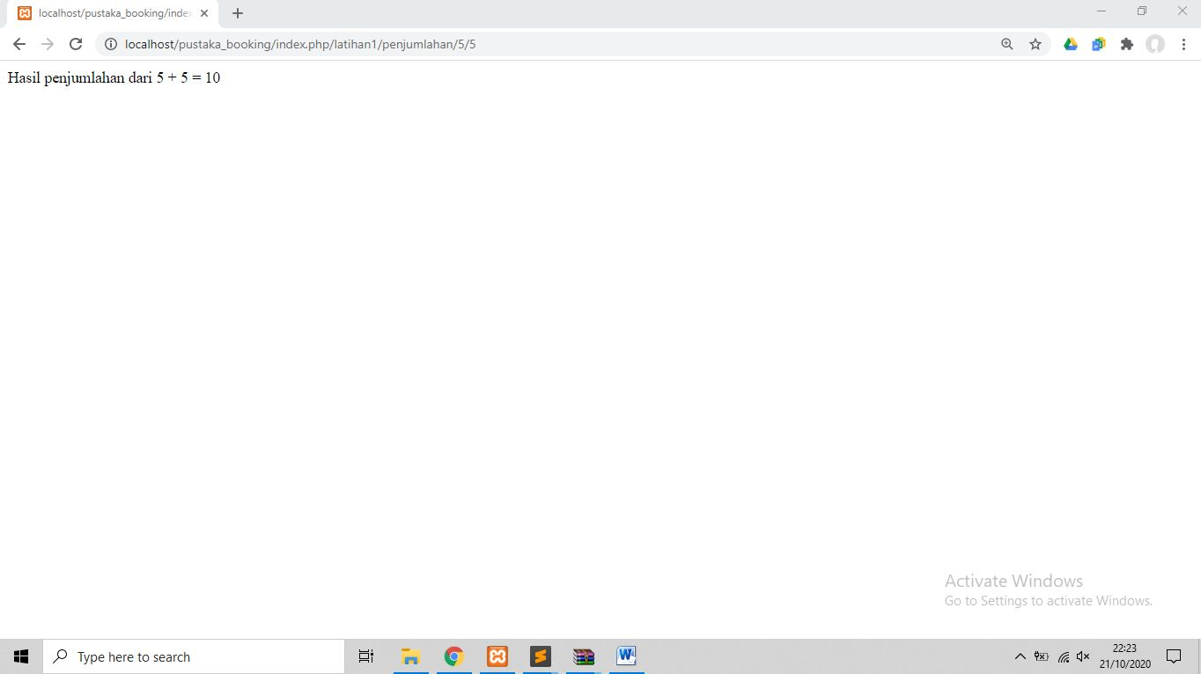

* latihan2 penjumlahan

